CS 499 5-2 Milestone Four
Jason Fuller - 2/8/2026

1. Briefly describe the artifact. What is it? When was it created?
The artifact selected for the Databases enhancement is the Python-based adventure game originally developed in IT-140: Introduction to Scripting in December 2023 and progressively enhanced throughout CS 499. In its original form, the project was a console-driven application that stored all game data in memory. Room definitions, item placement, and player state were hard-coded within a single Python file, and no persistence layer existed. When the application terminated, all user progress was lost. The system functioned correctly for instructional purposes but did not support multi-user interaction, persistent state, or structured data modeling.
Through this enhancement, the artifact has evolved into a database-backed application that integrates MongoDB Atlas for persistent storage. The system now supports user authentication, level storage, active game saves, and historical game results. Instead of embedding data directly into source code, structured collections are used to externalize content and session state. The result is no longer a temporary script but a stateful application capable of supporting multiple users and long-term gameplay continuity.

2. Justify the inclusion of the artifact in your ePortfolio. Why did you select this item? What specific components showcase your skills and abilities in algorithms and data structure? How was the artifact improved?
I selected this artifact because it demonstrates how deliberate database design can fundamentally transform an application. Rather than simply adding storage, this enhancement required thoughtful data modeling, separation of concerns, indexing strategy, and secure configuration. It illustrates not only technical competence with MongoDB but also architectural reasoning about how persistence should integrate with domain logic.
The enhanced system now includes separate collections for users, levels, active saves, and completed results. This separation was intentional. User identity is decoupled from gameplay data, active sessions are isolated from historical results, and level definitions are treated as validated, structured content rather than embedded constants. These design choices improve clarity and allow each collection to evolve independently without introducing unnecessary coupling.
Database access is managed through repository classes that abstract persistence logic from the rest of the application. Controllers do not communicate directly with MongoDB; instead, they interact with well-defined repository interfaces. This approach reinforces clean architectural boundaries, supports substitution with in-memory implementations during testing, and ensures that domain logic remains independent of database implementation details. By introducing this layer, I demonstrated an understanding that persistence is an infrastructure concern, not a core domain responsibility.
Index creation was also handled deliberately rather than reactively. Unique constraints were applied where identity integrity is required, and compound indexes were created to support actual query patterns such as leaderboard sorting and user history retrieval. These decisions were driven by application behavior rather than assumption. This reflects an understanding that database design must be informed by read and write patterns, not merely by data structure.
To support deployment and long-term maintainability, I implemented an idempotent bootstrap process that verifies indexes and seeds levels only when necessary. This ensures that initialization logic can safely run multiple times without duplicating data. The bootstrap approach mirrors production-style environment preparation and reinforces lifecycle awareness beyond simple development usage.
Security considerations were also integrated into the persistence layer. Database credentials are managed through environment variables rather than being embedded in source files. MongoDB Atlas is configured with restricted network access and encrypted connections. Test and production environments are separated through configuration controls, ensuring that automated tests do not accidentally target production resources. These decisions demonstrate a security-first mindset rather than retrofitting protection after functionality is complete.
This artifact belongs in my ePortfolio because it demonstrates growth from writing code that stores data to designing systems that manage data responsibly, securely, and predictably. It reflects architectural thinking rather than simple feature implementation.
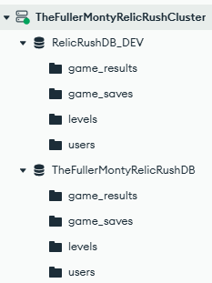
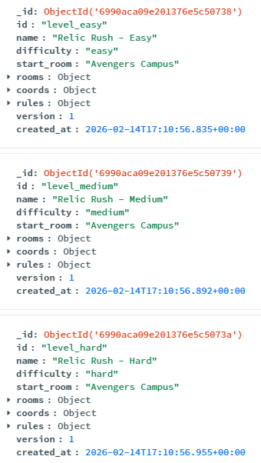
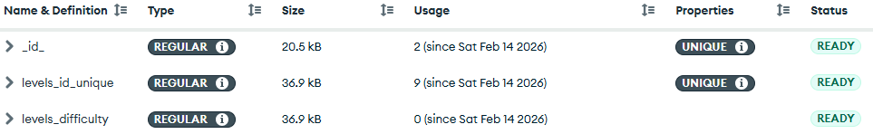

3. Did you meet the course outcomes you planned to meet with this enhancement in Module One? Do you have updates to your outcome-coverage plans?
The work completed for this milestone strongly aligns with the outcome coverage plans established in Module One. In particular, it demonstrates meaningful progress toward outcomes focused on professional computing practices and security-conscious design.
Outcome 4, which emphasizes the use of well-founded and innovative techniques in computing practices, is clearly represented through the integration of MongoDB Atlas, the repository abstraction layer, deliberate index design, and structured bootstrap logic. The system now reflects patterns commonly used in production services rather than classroom exercises.
Outcome 5, centered on developing a security mindset, is also strongly supported. Database credentials are managed securely, network access is restricted, encrypted connections are enforced, and test environments are isolated from production. These decisions demonstrate proactive mitigation of potential vulnerabilities related to data exposure and misconfiguration.
Outcome 1, which focuses on enabling collaborative environments, is indirectly supported through improved architectural clarity. The introduction of repository boundaries and structured collections makes the system easier to understand and extend, reducing friction for future contributors.

Outcome 2 is reflected in the clarity of documentation, organization, and intentional communication of design decisions. While the primary emphasis of this milestone is technical, the structure of the solution itself communicates professional standards and thoughtful engineering practices.
Overall, this milestone met and, in some areas, exceeded the original outcome coverage plan. The persistence layer is more structured and secure than initially envisioned, and the test isolation mechanisms added an additional layer of rigor beyond the original scope.

4. Reflect on the process of enhancing and modifying the artifact. What did you learn? What challenges did you face?
Enhancing the artifact’s persistence layer reinforced that database integration is not merely about storing information. It is about defining boundaries, enforcing invariants, and anticipating future evolution. The most significant lesson was that schema design must align with how the application behaves. Modeling collections based on query patterns and responsibilities made indexing decisions logical and defensible rather than arbitrary.
Another important realization was how strongly persistence decisions influence overall architecture. Early attempts that blurred the boundary between controller logic and database access increased coupling and reduced clarity. Introducing repository abstractions restored separation of concerns and significantly improved testability. This reinforced the principle that architectural discipline becomes increasingly important as systems grow in complexity.
Test isolation proved to be one of the more challenging aspects of the enhancement. Ensuring that automated tests could run repeatedly without contaminating state required careful fixture design and environment validation. While this added effort, it strengthened the reliability and professionalism of the artifact.
Security configuration also required deliberate planning. Managing credentials securely, enforcing encrypted connections, and restricting network access added complexity but made the system far more realistic and aligned with industry expectations. This experience reinforced that security must be designed into infrastructure from the beginning rather than applied later as a corrective measure.
Overall, this milestone transformed the artifact from an application that functions into a system that persists, protects, and organizes its data with intention. It deepened my understanding that database expertise involves architectural reasoning, operational awareness, and disciplined design, not simply the ability to execute queries.

